Name: Abdullah Imran

Roll no: 201026

Computer Network

Assignment No 1

1) 127.26.26.26

2) 127.52.52.52

3) 127.78.78.78

4) 127.104.104.4

5) 127.130.130.30

# 127.26.26.26

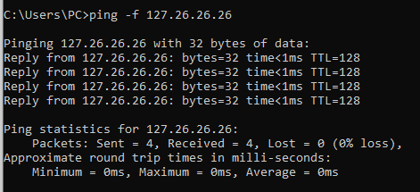

# 127.52.52.52

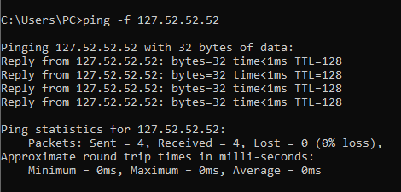

# 127.78.78.78

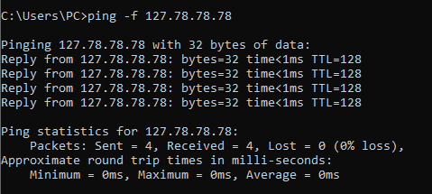

# 127.104.104.4

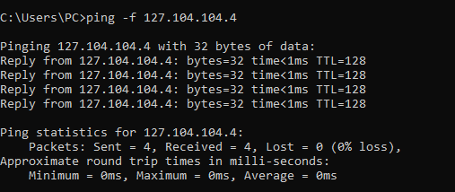

# 127.130.130.30

